**ITSMAP**

**Fall 2018**

**Project PoEtato**

**SMAP Synopsis V0R0**

**Participants:**

|  |
| --- |
| ***#1***  Stud.nr.: 201509807 Name: Ali Saleh Study Direction: Electronics |
| ***Date: 07-11-2018*** |

Contents

App Vision 2

Personal Vision 2

API Information and help 2

Context 3

Design Specifications 4

Additional Requirements 4

References 4

# App Vision

Path of Exile (PoE) is a free online game developed by Grinding Gear Games (GGG). They offer different APIs to developers, such as a Trade, League and Ladder.

The vision behind Project PoEtato is to create an Android application where Path of Exile users can use it to keep track of various elements within Path of Exile.

There already exists several different PC applications that uses these APIs, however the mobile market is very limited, and my goal is to bring some of my ideas into the Android market.

# Personal Vision

I have been playing PoE for a long time, and whenever I want to browse something PoE related outside of my PC, it is very difficult due to the low development of mobile apps within the game. Furthermore, even some of today’s PC applications do not satisfy my needs and thus I want to create my own PoE Application that can solve some of my issues and needs.

# API Information and help

The API is supplied by Grinding Gear Games and an Overview of the API Docs can be found in [1]. GGG’s customer support offer help regarding specific API questions. Furthermore, the PoE community help each other through Gamepedia [2] and the /pathofexiledev reddit page [3].

# Context

Following figure shows the current layout idea to develop the app. Note that the Trade button does not navigate anywhere currently, the Trade section has the lowest priority and explained later in this document.

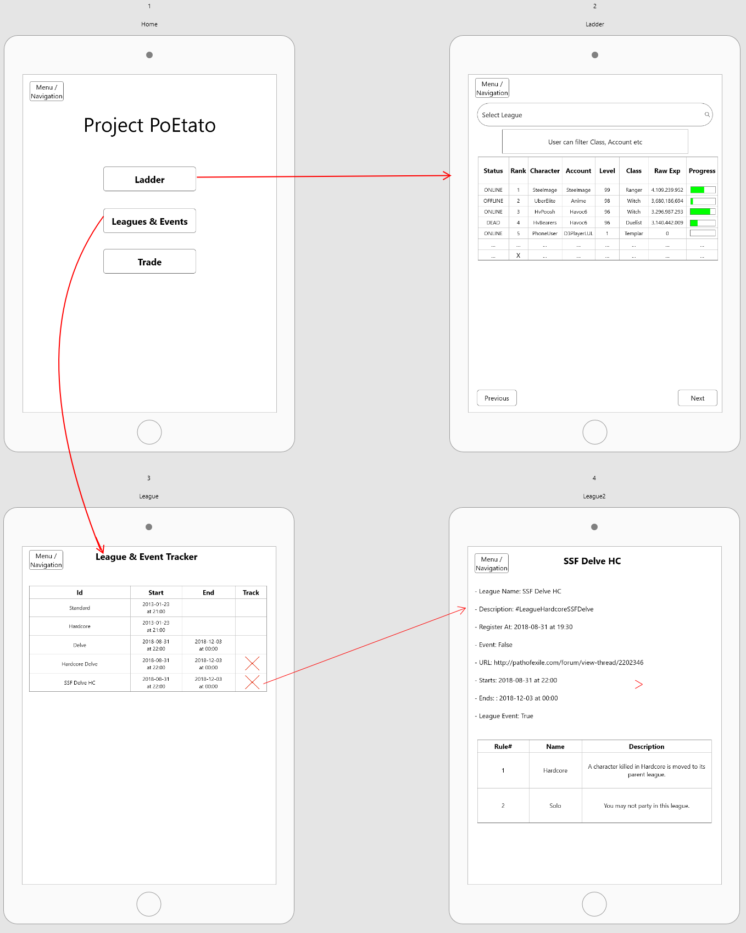

Figure 1: User Interface Design

## Design Specifications

1. **HomeActivity**: A simple introduction page where the user can choose between three buttons. The buttons will navigate to either LadderActivity, LeagueActivity or TradeActivity.
2. **LadderActivity**: This activity will display a list of the current ladder. The user can use the search bar to choose between the current ladders offered by the API. The Listview can be filtered by the user, which is offered just below the search bar. The two buttons will load the previous/next Ladder List.
3. **LeagueActivity**: To track the current and upcoming Leagues/Events offered by Path of Exile. The design will use a Listview to display the different leagues, and the user can click on an item to get a more details about the specific league.
4. **TradeActivity**: To Be Determined.
5. **LadderService**: A service to keep track of the data fetched from the Ladder API. This service will update every 10 min, while the LadderActivity is active.
6. **LeagueService**: This service will run when the user ticks a specific League in LeagueActivity. This service will update every 10 min from League API and will be active until all leagues are ticked off in LeagueActivity.
7. **TradeService**: This service will run every minute if the user is tracking a specific trade, multiple instances of this service can run depending on how many items the user wishes to track (a limit is intended, but not determined yet).
8. **Notifications**: Two notifications are to be developed. One for LeagueService when a new League/Event is discovered, and one for TradeService whenever a tracked item is available.
9. **Data Persistence**:
   1. User’s League & Trade data will be persisted in case of app is closed or phone restarted.
   2. This will be done through LiveData, ViewModel and Firebase as cloud storage.
   3. Firebase may be replaced with Room Persistens Library.
10. **BroadcastReceiver**: Activities/Services may send broadcast to access the Database or API.

## Additional Requirements

* Minimum API Level 21
* Locked Portrait Orientation
* Dark Color Scheme
* Swipe to return to previous Activity or click on the Menu Navigation button.

# References

[1] - <https://www.pathofexile.com/developer/docs/api>

[2] - <https://pathofexile.gamepedia.com/>

[3] - <https://www.reddit.com/r/pathofexiledev/>